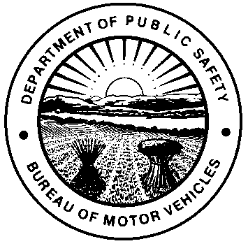 | OHIO DEPARTMENT OF PUBLIC SAFETY  BUREAU OF MOTOR VEHICLES  REGISTRATION APPLICATION OF PUBLIC OWNED VEHICLE | NO FEE

IMPORTANT INSTRUCTIONS
- Application must be fully completed; APPLICATION WILL BE RETURNED IF INCOMPLETE.
- Original certificate of title MUST be included (trailers less than 4,000 must include bill of sale or certificate of origin).
- Plates and registration will arrive separately.
- Emission test required for all vehicles registered in an E-check county.
- If requesting VOLUNTEER RESCUE plates, then also complete BMV 4523 and provide names, certification numbers and certification types of all volunteers associated with the rescue organization.
- If requesting C.A.P. plates, then please complete BMV 4523.
- If you need to cancel a Gratis registration, please notify Registration Support Services in writing.
- Gratis plates may not be displayed on vehicles used for private/for-profit/commercial purposes.

CHECK APPROPRIATE BOXES BELOW
REGISTRATION TYPE  NEW  TRANSFER  REPLACEMENT PLATE  DUPLICATE REGISTRATION  PLATE NUMBER  NUMBER OF PLATES  1 2  (If New or Replacement transaction only) | AGENCY TYPE  CITY / VILLAGE  COUNTY / TOWNSHIP  GOVERNMENT (FEDERAL)  STATE | PLATE TYPE  ACCESSIBLE  VOLUNTEER RESCUE  C.A.P. (Ohio Wing)  TURNPIKE  (Turnpike Commission ONLY)  NATIONAL GUARD  (Adjutant General)  *ONLY SELECT IF APPLICABLE | VEHICLE CLASS  PASSENGER VEHICLE/VAN  TRAILER  TRUCK / CARGO VAN  HOUSE VEHICLE  MOTOR HOME  MOTORCYCLE  BUS  RECREATIONAL VEHICLE

FEDERAL TAX IDENTIFICATION NUMBER ONLY |  |  | E-CHECK IDENTIFICATION NUMBER (Only if you are residing in an E-Check county).
BUSINESS NAME |  |  |  | ADDRESS
CITY |  |  | ZIP CODE |  |  | COUNTY
CONTACT PERSON (PLEASE PRINT) |  |  |  |  |  | TELEPHONE NUMBER  EXT.
JOINT OWNER / LESSEE NAME |  |  |  | LESSEE TAX ID NUMBER
MAILING ADDRESS (IF DIFFERENT) |  |  |  | E-MAIL ADDRESS
VEHICLE SERIAL NUMBER |  |  |  | DATE PURCHASED |  | TITLE NUMBER
YEAR | MAKE | MODEL |  |  | BODY TYPE |  | COLOR

If registering a motor vehicle, I affirm that all owners (or lessees of leased vehicles) now have insurance or other FR coverage and will not operate or permit the operation of this motor vehicle without FR coverage. I also affirm that, in accordance with Ohio Revised Code 4503.16, this vehicle will be used exclusively in the performance of the governmental or proprietary functions of the state or any political subdivisions thereof.
SIGNATURE  X | DATE

MAIL TO:

OHIO BUREAU OF MOTOR VEHICLES
ATTN: REGISTRATION SUPPORT SERVICES
P.O. BOX 16521
COLUMBUS, OHIO 43216-6521

DIRECT INQUIRIES TO (614) 752-7518 or Fax (614) 995-4739
www.bmv.ohio.gov

