
Hocking Hills Conservation Association
Hemlock Woolly Adelgid (HWA) Treatment Equipment Kit

Table of Contents
- Kit Contents
- Eligible Products List & PPE
- Mixing Instructions
- Choosing an Application Method
- Application Instructions
- Cleaning Equipment

Please note: Every pesticide product label is different and should be followed. The instructions in this document include optimized mixing and dosage rates for the application of imidacloprid 2F products for the control of hemlock woolly adelgid (HWA). The optimized mixing and dosage rates are based on research and allow for application rates lower than label rates. This allows treatment of more trees with less pesticide. For more information see, “Optimized Insecticide Dosage for HWA Control” available for download at OhioDNR.gov/HWA.

Kit Contents
This equipment is for the purpose of hemlock treatments for the invasive insect, hemlock woolly adelgid (HWA) with an imidacloprid 2F insecticide. The equipment in this kit can be used for soil drench and bark spray applications.
This kit includes:
- Storage tote
- 1 chemical-resistant 18” x 18” containment tray (for pesticide mixing and equipment cleaning)
- 2 measuring pitchers 32 oz
- 4 Nalgene bottles 48 oz
- 2 Husqvarna handheld sprayers 48 oz
- 2 tree diameter tapes
- Instructions
Items NOT included, but necessary for safe pesticide application:
- Imidacloprid chemical insecticide (see next page for approved pesticide options)
- Chemical-resistant gloves (i.e., nitrile)
- Paper towels
- Trash bag
- Flagging or tree-marking paint to track and identify treated trees
- Toolbelt, backpack, bucket or other container to transport the Nalgene bottles of mixed imidacloprid solution – choose something that can be cleaned or designated for pesticide usage only

Eligible Products & PPE

Eligible Products
The following 21.4% imidacloprid 2F pesticides are approved for treatments of adelgids in a forest setting:
- ImiGold® 2 F - UPL NA Inc.
  - EPA Reg. No. 70506-150
- Lesco® Bandit™ 2F - Bayer Environmental Science
  - EPA Reg. No. 432-1312
- Mineiro™ 2 F Flex - Atticus EcoCore
  - EPA Reg. No. 91234-304
- Mineiro™ 2 F - Atticus EcoCore
  - EPA Reg. No. 91234-137
- Lada® 2F - Albaugh, LLC Specialty Products
  - EPA Reg. No. 83100-6-83979
- Merit® 2F - Bayer Environmental Science
  - EPA Reg. No. 432-1312
- Merit® 2F Insecticide - Environmental Science U.S., LLC
  - EPA Reg. No. 101563-60
- Malice® 2F - Loveland Products, Inc.
  - EPA Reg. No. 34704-893
- Mallet® 2 F T&O Insecticide - Nufarm Americas, Inc.
  - EPA Reg. No. 228-695

Personal Protective Equipment (PPE)
PPE required for imidacloprid treatments may vary by pesticide product label. Standard PPE for imidacloprid 2F products include: long sleeves, pants, shoes, socks, and gloves. Please refer to the pesticide label for the product you are using for further PPE requirements.

Mixing Instructions
All insecticide mixing should be done within the containment tray. Wear appropriate PPE as listed on the pesticide label. Any spills within the tray should be wiped up with paper towels and disposed of in trash. Proper disposal procedures for pesticide containers can be found on the pesticide label. Standard procedure includes triple-rinsing and then puncturing the container before disposal. Rinse water can be saved and used for mixing.
Note: Only mix what you plan to apply that day. Mixed pesticide suspension may settle to the bottom of the container and harden making it unusable if left to sit over several days.
Mix directly in 48 oz Nalgene container
- Add 7 oz of imidacloprid 2F product to each Nalgene bottle.
- Fill Nalgene bottle with water to the 48 oz line.
- Secure lid and shake bottle to mix solution.

Pesticide Spills
- In the event of a liquid pesticide spill, follow the three C’s.
  - Control the spill – Turn the spilled container upright. If equipment is leaking, place it inside of another container.
  - Contain – Use a mound of dirt or other material around the edge of the spill to keep it from spreading.
  - Clean up – If a spill occurs in the hemlock forest, move contaminated soil and leaf litter to a nearby target hemlock tree. If not in the hemlock forest, liquid spills can be soaked up with special spill sponges, soil, sawdust, cat litter or other absorbent material. Sweep or shovel the spill and cleanup materials into a plastic container for disposal.

Before starting treatments
- Determine how you will transport the mixed insecticide solution to your treatment area and from tree to tree.
  - Backpack, toolbelt, sling bag, bucket, or other container designated for pesticide use
  - Consider lining the bags or other containers with a plastic trash bag to limit possible pesticide contamination
- Determine how you will keep track of how many trees you treated.
  - Keep a tally on paper, a clicker counter, take notes on phone, etc.
  - Remember you will need to report an estimate of the number of trees treated and the acreage of your treatment area when returning this kit.

Choosing an Application Method
Imidacloprid is highly toxic to aquatic invertebrates and pollinating insects such as bees. Avoid soil applications near insect-pollinated trees and shrubs or within 10 ft of any surface water. Use the chart below to help determine the most appropriate treatment method. If none of these conditions are present, either application method can be used and are equally effective.
Conditions | Soil Drench | Bark Spray
  Raining |   If light rain, | 
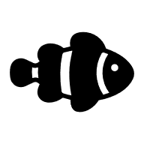  Within 10 ft. of surface water |  | With caution,
Within 10 ft. of flowering trees *   |  | If possible, without overspray,

Drought conditions

  On cliff edge or steep slope |  | With caution,
Water-logged soil   |  | Okay if soils are not usually wet
*See included Insect-pollinated Tree & Shrub guide for assistance identifying insect pollinated species commonly found in hemlock stands:

- Yellow-poplar / tuliptree
- Blackgum
- Sassafras
- Sourwood
- Black cherry
- Basswood
- Mountain laurel
- Spicebush

Application Instructions
A specific dosage of imidacloprid 2F solution should be applied based on the diameter of the tree’s trunk. To determine diameter at breast height (DBH) in inches, use a diameter tape provided in the kit and measure around the tree. DBH is measured 4.5 feet above the ground, standing on the uphill side of the tree. If the tree has multiple stems, measure each stem separately and add them together to determine the dosage (example below). Only measure stems that are alive.
Split Trunk Measurement Example:
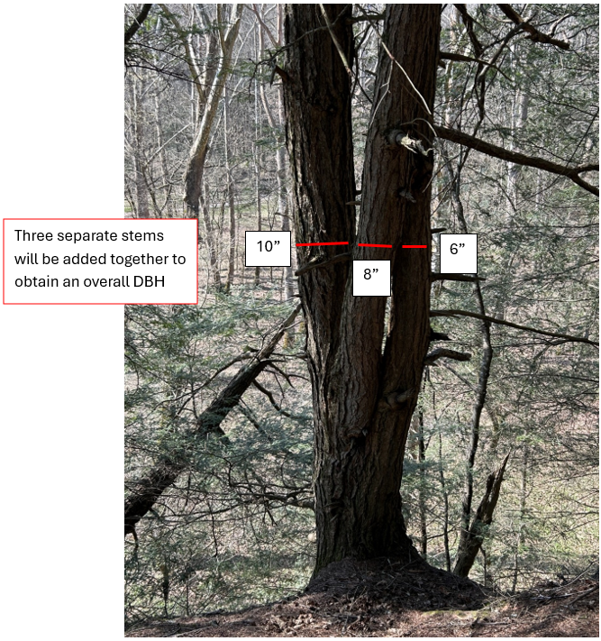
Overall DBH: 10” + 8” + 6” = 24”
Dosage Amount: 21 oz imidacloprid solution

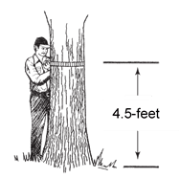
Measuring DBH

Dosage Chart

This chart shows doses of mixed imidacloprid solution for soil drench or bark spray application on eastern hemlock trees. The tree’s DBH (blue number) in inches has a corresponding dosage in ounces (red number) of mixed solution to be applied. Find this dosage chart taped on the diameter tapes in the kit. You may also want to take a picture of the chart for reference on a phone in the event the taped-on copy falls off. The dosage chart above was developed through research finding treatment volumes less than the label rate to be effective.

Soil Drench
- Measure the DBH, rounding to the nearest inch.
- Determine the quantity of mixed imidacloprid solution to be applied using the dosage chart.
- Within 1 foot of the base of the tree, scrape back the leaf litter, creating a shallow trench down to the bare soil where fine roots are visible.
- Measure out the appropriate amount of mixed imidacloprid solution based on the dosage chart into measuring pitcher.
- With the measuring pitcher low to the ground, slowly pour out the chemical, evenly distributing it on the exposed soil.
- Re-cover the soil and solution with duff and leaf litter. Ensure no chemical is left exposed.
- Mark the base of the tree trunk with a small spot of tree-marking paint on both the uphill and downhill-facing sides (or use other marking method).

Bark Spray
- Measure the DBH, rounding to the nearest inch.
- Mark the base of the tree trunk with a small spot of tree-marking paint on both the uphill and downhill-facing sides (or use other marking method).
- Determine the quantity of mixed imidacloprid solution to be applied using the dosage chart.
- Clear any debris from measuring pitcher and pour the appropriate amount of mixed imidacloprid solution based on the dosage chart into measuring pitcher.
- Pour chemical into basal sprayer and pump to pressurize. Adjust nozzle to coarse droplet spray pattern.
Note: Avoid using too fine of a mist that may result in drift, or too straight of a stream that may result in chemical bouncing back off of the tree.
- Spray insecticide solution onto bark of tree from ground level to 4.5 feet high on the trunk all the way around the tree.
- Spray until empty.
- Once the basal sprayer is empty, release the pressure using the pressure release valve on the sprayer.

Cleaning Hemlock Treatment Equipment
Materials Needed: Paper towels, containment tray, trash bag, personal protective equipment (PPE)
- All cleaning of pesticide application equipment needs to occur within a containment tray
- Proper PPE is required (see pesticide label – common PPE includes gloves, long sleeves, long pants, socks, closed-toe shoes)
Measuring Cups
- Rinse the measuring cup three times with water
- Apply rinsate to a hemlock on the property
- Wipe clean with paper towels to remove any remaining residue and dry
Basal Sprayers
- Remove lid from sprayer
- Rinse the sprayer tank twice with water and apply rinsate to a hemlock on the property
- Use wet paper towel to wipe down all surfaces of sprayer lid
- Swirl nozzle and straw pieces in a measuring cup with clean water
- Fill sprayer basin ¼ full with water, reassemble sprayer and spray onto a hemlock on the property

