Tree Planting 101: What to do and What not to do
Dani Gill, Hocking SWCD
Have you ever considered planting a tree or many trees in or around your home? There are several things to consider when planning a tree planting: What, when and how. Tree planting isn’t as simple as purchasing, planting and hoping for the best. There is a process that goes into deciding the proper species, location and maintenance to ensure the success of your planting.
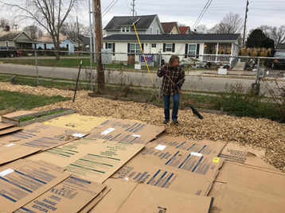
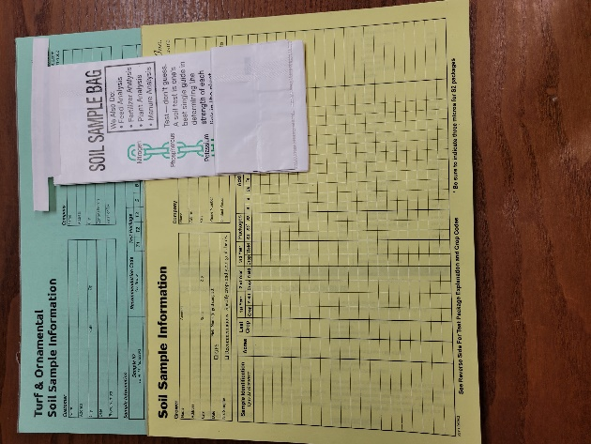
When first thinking of planting, consider tree species. There is always a ‘best’ site for tree planting depending on the species you are considering. Planting a river birch (Betula nigra) on a ridgetop would be an example of poor placement, while planting a sugar maple (Acer saccharum) on a semi-dry site would be an example of good tree selection and placement. Certain trees need drier or wetter conditions to thrive. Planting cultivar species, such as ‘Autumn Glory Red Maple’ vs. straight red maple (Acer rubra) is something to keep in mind. Typically, cultivars have been genetically selected for certain traits (flower color/shape/scent or tree height). This process can alter the tree and make individual trees less desirable or beneficial to local pollinators and wildlife. The next step is soil testing. Soil test bags for plantings, big or small, can be picked up from your local Soil and Water Conservation District (SWCD). You will send the sample to a testing facility. Upon receiving the results, they can be brought into the SWCD or Natural Resource Conservation (NRCS) office for interpretation, if needed. Your soil may need amended with lime, fertilizer, or compost. Conducting a soil test helps landowners establish a base line and decide what is needed to help their tree planting. Then site preparation should be conducted, this may be done by hand or mechanically. Hand site prep could be laying cardboard around an area where you plan to plant a few trees. This will help kill the grass in an area to help give the tree more of a fighting chance. Herbicide can also be used in areas but be sure to read the label to make sure the vegetation you are trying to remove is a target species for that herbicide. With herbicides, the label is the law and must be followed. Mechanical site prep is preparation using mechanized equipment such as tillers, tractors or mechanized land clearing and mulching equipment (such as Fecon or Hyrdo-ax). Generally, mechanical site prep is used when large areas are being planted with trees, such as plantations or reforestation.
Laying cardboard to kill grass for hand site preparation. Then cover with mulch to help hold cardboard down and decompose it.
Soil test bag and sample form.
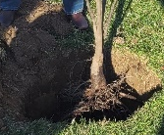
After choosing the right tree(s) to plant on your site and getting the area ready for planting, you will need to decide where to purchase trees. In Ohio, we have a great list compiled by ohionativeplantmonth.org of local nurseries, but for larger plantings, you may need to source out your trees. There are a few larger nurseries in and around Ohio and surrounding states. Some SWCDs also conduct tree sales typically January-February with tree pick up in April. Therefore, it is important to begin thinking of tree plantings early instead of waiting until spring to purchase trees and plant them. Sometimes lower quantities at nurseries make it harder for landowners to reach their goals in a timely manner.
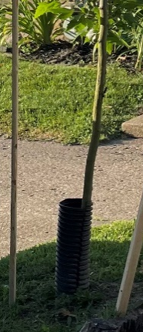
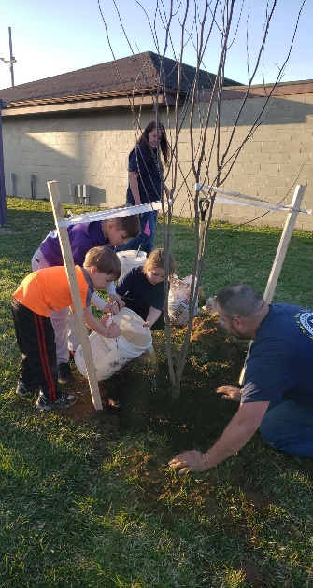
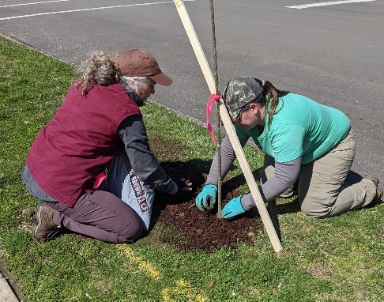
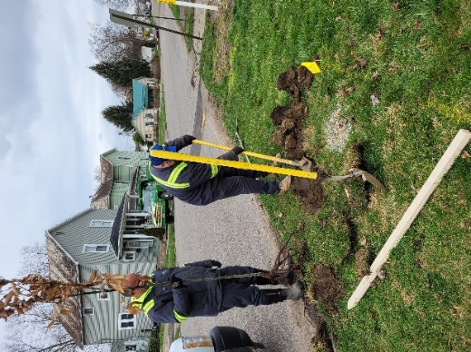
Finally, we reach the planting process. Planting consists of the ‘how’. There is a proper technique to planting trees to help with tree survival. Planting individual trees can usually be done by hand. When planting, it is recommended to call the Ohio Utilities Protection Service (OUPS) to be sure tree placement does not interfere with utilities. Hand dig a hole that is 1.5-2 times as wide as the size of the roots and only as deep as the root flare (base of the trunk that begins to ‘flare’ just before the roots). This helps roots grow out instead of around the trunk, choking the tree. Mulch should be no more than 3-inches thick around the base of trees but not touching the trunk. It should be in a doughnut shape (even height, but not touching the trunk). Many young trees become rotted because mulch touches the tree and is in the shape of a volcano up the stem. This allows moisture to sit on the stem instead of reaching the roots for uptake resulting in stem rot. Young trees should be given the equivalent 5 gallons of water per inch in diameter (measured at 4.5’ above ground level) per week, whether supplied by you or rain. Lastly when hand planting, protection needs to be added to the base of the tree to protect against weed trimmers and lawn mowers. Tree tubes, protectors or fencing may be purchased or a piece of 6-in corrugated drainpipe that is 14-18 inches long can protect the tree for the time it takes to become established (2-3 years). Lawn mowers, weed trimmers and lack of water are the top culprits of a failed planting. Young tree maintenance in the first 2-3 years is crucial for survival.
Dig hole approximately 1.5 times the size of the roots and as deep as the root flare.
Cub scouts watering a tree after planting at Mingo Park.
Mulch tree in a doughnut shape, ensuring mulch doesn’t touch stem.
OUPS area prior to planting. Then measure past root where you intend to place tree.
Planting many trees for plantations or reforestation can be done a few different ways. You (and helpers) can use tree planting bars to push the soil back, place tree in the hole and use the bar to gently push the soil back, seating the tree in the soil. You can also us a mechanical tree planter. These are 2-man pieces of equipment used to create a trench in the ground for seedlings to be placed in and closing wheels to close the trench after placement. One person pulls the planter with a tractor while the other sits on the planter placing the seedlings in the trench. After planting, usually the watering is done with rain so planting with rain in the near forecast is recommended. It is also recommended to plant extras as there are several reasons a seedling may not survive- wildlife browsing, stress and lack of water to name a few. Tree guards or shelters can be installed on all or some of your seedlings but require annual or bi-annual maintenance to remove leaf build up, wildlife or insect nests and to check seedling survival. A tree shelter doesn’t ensure survival, but when done correctly, will give a better chance for survival.
Corrugated pipe used as tree protector.
When planning to plant trees, whether it be a few or many, it is a good idea to work with a natural resource professional to be sure the site selected is good for the tree(s) you intend to plant. They could also assist with recommendations for the number of trees for an area. While planting can seem a daunting task, it can be a rewarding adventure also. Watching that young tree you planted now grow and flourish is an amazing venture that can be shared with family and friends. Happy January and happy planting!

